Using a Cell-line Luminometry Assay to Investigate the Role of Lentiviral Accessory Proteins in Antagonising Anti-viral DNA-Sensing Pathways
  - By James Cai

Background
With the support of the Pathological Society Undergraduate Bursary, I undertook a 6 week placement at the Towers Lab. The Towers Lab is an internationally renowned lab investigating molecular details of host-virus interactions. Studying these interactions not only elucidates potential novel targets for therapeutic interactions, but also allows viruses to be used as dissecting tools to understand components of the innate immune system.

Abstract
Viral protein X (Vpx) is a viral accessory protein encoded in the genome of HIV-2 and most Simian Immunodeficiency Viruses (SIVs). Previous work by the Towers lab has discovered that distinct from its established roles, Vpx antagonises NF-kB activation downstream of DNA-sensing. I have used a cell-line luminometry assay to characterise this interaction further. A notable finding from an experiment involving mouse and human STING suggest that this action of Vpx occurs downstream of cGAS/STING activation.

Introduction
Recently, research into DNA-sensing pathways of the innate intracellular immune system has provided an entirely new avenue of targeted therapies against Human Immunodeficiency Virus (HIV). As HIV must form viral DNA through reverse transcription before it is integrated into the nucleus, it is vulnerable to these pathways. The importance of DNA-sensing pathways in host immune defences is shown by the evolution of HIV accessory proteins. Accessory proteins such as Vif, Vpu and Vpr have developed sophisticated methods of antagonism; without which replication would not occur(1,2).
Whilst all lentiviruses encode the accessory protein Vpr, viruses in the HIV-2/SIVsm/SIVmac lineage encode an additional unique accessory protein, Vpx(3). Vpx is thought to have arisen from a duplication of Vpr and thus shares significant functional and structural similarities with Vpr(4). In the literature, Vpx has been described to mediate degradation of a host restriction factor, SAMHD1 through recruiting a host protein DCAF1 (DDB1- and CUL4-associated factor 1), which targets it for proteasomal degradation(5,6). More recently, Vpx has been discovered to counteract the HUSH complex, which allows it to overcome transcriptional repression of proviruses(7).
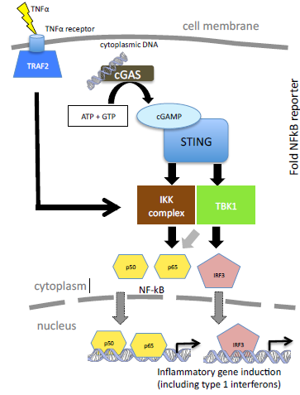
An integral DNA-sensing pathway is made up of the Pattern Recognition Receptor (PRR) cyclic GMP-AMP Synthase (GAS) and its adaptor protein STING (Stimulator of interferon genes). cGAS binds to foreign cytosolic DNA and forms the second messenger cGAMP, which in turn activates STING. (8) Activation of STING leads to a signalling cascade which leads to activation of NF-kB and IRF3 (Figure 1). This results in a vigorous inflammatory response and Type I interferon release. Previous studies have shown that the cGAS/STING pathway detects HIV-1 DNA in human myeloid cells(9), and that evasion of the subsequent intracellular innate response is fundamental to successful replication(10).
Figure 1. NF-kB and IRF3 activation by cGAS/STING or TNFα.
Cartoon model of cGAS/STING and TNFα activation of NF-kB and IRF3 transcription factor leading to induction of inflammatory genes.
My supervisor’s laboratory has discovered that Vpx antagonises NF-kB activation, though the exact mechanism of antagonism is yet unclear. The group propose a novel phenotype of Vpx as a NF-kB signalling antagonist, thus enhancing evasion of key defence mechanisms and promoting viral replication.
My project aims were to:
- Use a cell-line luminometry assay to observe the effect of Vpx on NF-kB activation, and check previous observations were reproducible.
- Further characterise Vpx antagonism of NF-kB activation by using components of the cGAS/STING axis from phylogenetically diverse species, in the established luminometry assay.
- Use structural biology knowledge of Vpx to generate novel mutant Vpx proteins by site-directed mutagenesis, and test these mutant proteins in the assay to observe the impact of specific Vpx residues on the phenotype of Vpx as a DNA-sensing antagonist.
My personal objectives were to:
- Develop a formal understanding of scientific method
- Acquire a range of key molecular biology techniques
- Experience working in a science community and better inform myself of my future training and career plans.

Methods:

Cell Culture
Human Embryonic Kidney (HEK) 293T Cells were cultured in Dulbecco’s Modified Eagle’s Medium (DMEM, Gibco) supplemented with 10% FCS and 50µg/ml Penicillin Streptomycin. These cells were maintained by splitting on Monday, Wednesday and Friday and regularly tested for mycoplasma contamination.
Transfection
293T cells, lacking in several innate antiviral defence pathways, were made to transiently over-express cGAS/STING through chemical-based transfection, using FuGENE® HD (Promega). Cells were seeded at 1 x10⁵ cells per ml 24h before transfecting with plasmids containing cGAS, varying doses of mouse or human STING, a reporter mix (containing an NF-kB linked Luciferase Reporter and a TK- Renilla Reporter) and a constant 100ng dose of Vpx. Empty vector containing pcDNATM3.1⁽⁺⁾ (Thermofisher) was added to keep maintain equal doses of DNA.
Luciferase Assays
HEK293T cells were seeded in 24-well plates at 1 x 10⁵ cells per ml, and transfected 24h later with 10ng per well of firefly luciferase under the control of an NF-kB promoter, and 5ng per well of pRL Renilla Luciferase to act as a control. Empty vector containing pcDNATM3.1⁽⁺⁾ (Thermofisher) was added to keep doses of DNA constant. Transfections were carried out using 1.5µl FuGENE®HD Transfection Reagent (Promega), and cells were lysed in Passive Lysis Buffer 24h post transfection, and stored overnight at -20°C. 20µl of each sample was transferred to a 96-well plate and 30µl of firefly luciferase substrate added before measuring with a GloMax 96 Microplate Luminometer (Promega). After making 3 repeat measurements 30µl of Stop & Glo® (Promega) was added to stop luminescence from firefly luciferase, and provide substrate for Renilla luciferase. This was then measured similarly using the GloMax Luminometer. Firefly luciferase activity was measured and normalised to Renilla luciferase activity in each sample. Finally, results were then normalised to background luciferase with empty vector (0ng of cGAS/hSTING; 0ng of Vpx), to allow effective comparison.

Results and Reflections:

Vpx antagonises NF-kB activation from human cGAS/STING
The HEK293T cell line was used due to their reliable growth and high propensity for transfection. However, these cells do not express detectable levels of STING(11) so varying doses of human STING (hSTING) were transfected in an over-expression assay, to observe if a constant dose of Vpx would antagonise the NF-kB activation that would usually follow cGAS/STING activation. It is clear that doses of hSTING lead to an increase in NF-kB activation (Figure 2), though the fold induction is one order of magnitude lower than previously observed in previous experiments. This is thought to be due to lack of optimisation in cell confluence, transfection efficiency and the high passage number of the cells used in the experiment. The experiment also shed light on optimum doses of hSTING to use in future experiments, as it became apparent that doses of 20ng of hSTING led to death of many cells, and thus a lower fold induction than anticipated. The experiment made apparent that a dose of 5ng hSTING led to a clear induction of NF-kB, so informed future experiments to measure at lower concentrations of hSTING. However, it is still clear that Vpx decreases NF-kB activation at all doses of hSTING, confirming the results of previous experiments made by the lab.
Figure 2. Vpx antagonises human cGAS/STING activation of NF-kB reporter.
293T cells were transfected with plasmids containing NF-kB Sensitive luciferase reporter, cGAS, varying doses of human STING (hSTING) +/- SIV_{MAC}251 Vpx. Reporter assay data are presented as means with S.D. (n=3)

Vpx antagonises mural cGAS/STING activation of NF-kB, suggesting antagonism is downstream of cGAS/STING activation
Having confirmed the group’s previous findings, I wanted to further characterise the antagonism of Vpx on NF-kB. Principally, I wanted to assess if Vpx antagonism was acting to inhibit cGAS/STING activation directly, or whether antagonism acted downstream of this. To investigate this, I used the same overexpression assay transfecting murine STING (mSTING) as opposed to human STING. In the literature, it has been established that mSTING and hSTING have various dynamic structural differences, which has led to the failure of antitumour agents that could selectively target mSTING, but were unable to bind hSTING(12). I therefore wanted to observe if this Vpx phenotype was conserved on cGAS and STING from different species. It is apparent in Figure 3 that the same phenotype is present- doses of mSTING lead to an induction in NF-kB, which is then reduced by Vpx, to lessening degrees with higher doses of STING. As the structures of mSTING and hSTING differ so greatly, it suggests that Vpx does not inhibit NF-kB induction through directly binding to and inhibiting cGAS/STING activation, as the phenotype would not be conserved across different species. However, it is clear that there is still a need for optimisation in this experiment, and it would be desirable to repeat with lower doses of STING, to better observe the dose-response effect. Unfortunately, I did not have sufficient time to do this at my placement, as the latter half of my project was focused on generating mutants of Vpx to test.
Figure 3. Vpx antagonises murine cGAS/STING activation of NF-kB reporter.
293T cells were transfected with plasmids containing NF-kB Sensitive luciferase reporter, murine cGAS, varying doses of murine STING (mSTING) +/- SIV_{MAC}251 Vpx. Reporter assay data are presented as means with S.D. (n=3)

Site Directed Mutagenesis
The latter half of my project was spent trying to make specific site mutations of SIV_{MAC}251 Vpx using Site Directed Mutagenesis, but ultimately this was unsuccessful. Nonetheless, this process proved a valuable experience and gave me genuine insight into the process of research and troubleshooting. Repeating the protocol over several weeks, making slight alterations to certain parameters was often a testing process, when each iteration was still without success. This was a challenge that I was not used to, having gone through two years of medical school where answers were readily available. Furthermore, the complexity and multiple stages of each protocol highlighted how a small error in just one stage could ultimately end in failure, meaning exact errors were difficult to isolate. This taught me the value of writing clear, detailed procedure notes to ensure that between weeks, the exact method was reproduced. Whilst I was unsuccessful in generating mutants during the course of my placement, I was able to appreciate how a systematic approach in changing one parameter at a time helped in eventually isolating the cause of the problem. Indeed I was later informed by my supervisor that following my placement, after making our next planned change to the parameters, the protocol was successful.
The process of troubleshooting also emphasised the collaboration that underlies scientific research. We would frequently consult other researchers who had more experience, or have discussions with other scientists going through the same difficulties to share ideas and theories of what parameters to change. The sense of solidarity and community between researchers in the lab was often very reassuring, and it showed me the clear benefit to science that the sharing of ideas and knowledge brings.

Other General Reflections
Being immersed in a scientific environment has been an absolutely thrilling experience. Regularly attending internal seminars, laboratory meetings and journal clubs has developed my skills in critical analysis and presenting ideas. More importantly, it has taught me to challenge the information I come across, and not rely on dogma. In my first two years of medical school, most of my learning came from memorising information presented to me, but I have since seen that information should not be treated as plain fact, and that evidence supporting the information should be suitably scrutinised and interpreted before accepting it. I am very grateful for this placement in teaching me to truly think for myself.
Working with my supervisor has helped me better ascertain my future training pathway and further cement my desire of a clinical career involving academic research. It was clear that the skills gained from research supplemented and developed my supervisor’s clinical practice. Furthermore the rewarding nature of being able to wholly understand and make discoveries pertaining to the cause of certain diseases would provide an additional aspect that Medicine would not.
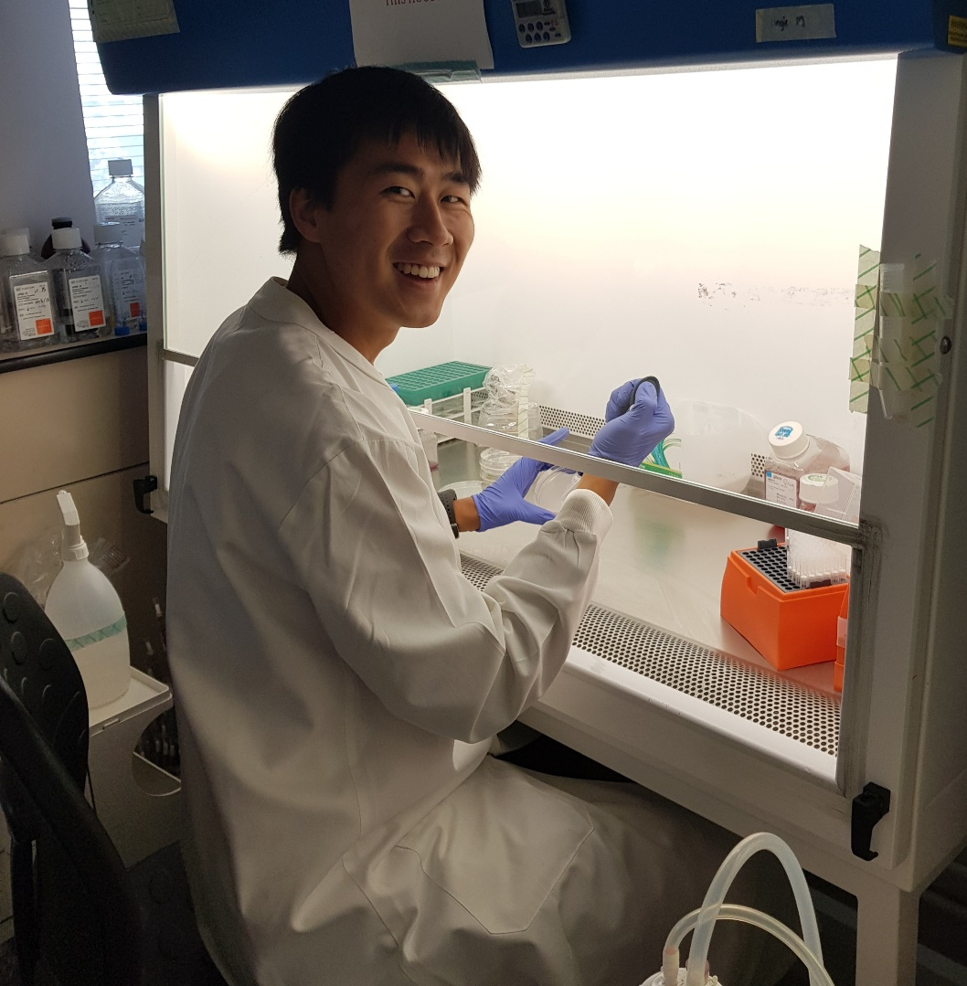
I am very grateful for the Pathological Society for supporting me for my placement, which represents my first foray into academic research. It has been an absolutely incredible experience, but has also been vital in breaking past the glitz and glamour of discovery science. Being able to see the realities of troubleshooting and optimisation could be harrowing at times, but ultimately, the reward of contributing towards the generation of novel knowledge leaves me enthusiastic and excited for my next adventure in academic research.

1. Sumner RP, Thorne LG, Fink DL, Khan H, Milne RS, Towers GJ. Are evolution and the intracellular innate immune system key determinants in HIV transmission? Front Immunol. 2017;8(OCT):1–23.
2. Strebel K. HIV accessory proteins versus host restriction factors. Curr Opin Virol. 2013 Dec;3(6):692–9.
3. Planelles V, Barker E. Roles of Vpr and Vpx in modulating the virus-host cell relationship. Mol Aspects Med. 2010 Oct;31(5):398–406.
4. Sakai Y, Miyake A, Doi N, Sasada H, Miyazaki Y, Adachi A, et al. Expression Profiles of Vpx/Vpr Proteins Are Co-related with the Primate Lentiviral Lineage. Front Microbiol. 2016;7:1211.
5. Laguette N, Sobhian B, Casartelli N, Ringeard M, Chable-Bessia C, Ségéral E, et al. SAMHD1 is the dendritic- and myeloid-cell-specific HIV-1 restriction factor counteracted by Vpx. Nature. 2011 May 25;474(7353):654–7.
6. Srivastava S, Swanson SK, Manel N, Florens L, Washburn MP, Skowronski J. Lentiviral Vpx Accessory Factor Targets VprBP/DCAF1 Substrate Adaptor for Cullin 4 E3 Ubiquitin Ligase to Enable Macrophage Infection. Luban J, editor. PLoS Pathog. 2008 May 9;4(5):e1000059.
7. Yurkovetskiy L, Guney MH, Kim K, Goh SL, McCauley S, Dauphin A, et al. Primate immunodeficiency virus proteins Vpx and Vpr counteract transcriptional repression of proviruses by the HUSH complex. Nat Microbiol. 2018 Oct 8;1.
8. Wu J, Sun L, Chen X, Du F, Shi H, Chen C, et al. Cyclic GMP-AMP is an endogenous second messenger in innate immune signaling by cytosolic DNA. Science. 2013 Feb 15;339(6121):826–30.
9. Gao D, Wu J, Wu YT, Du F, Aroh C, Yan N, et al. Cyclic GMP-AMP synthase is an innate immune sensor of HIV and other retroviruses. Science (80- ). 2013;341(6148):903–6.
10. Rasaiyaah J, Tan CP, Fletcher AJ, Price AJ, Blondeau C, Hilditch L, et al. HIV-1 evades innate immune recognition through specific cofactor recruitment. Nature. 2013 Nov 6;503(7476):402–5.
11. Rausell A, Muñoz M, Martinez R, Roger T, Telenti A, Ciuffi A. Innate immune defects in HIV permissive cell lines. Retrovirology. 2016;13(1):43.
12. Shih AY, Damm-Ganamet KL, Mirzadegan T. Dynamic Structural Differences between Human and Mouse STING Lead to Differing Sensitivity to DMXAA. Biophys J. 2018 Jan 9;114(1):32–9.

